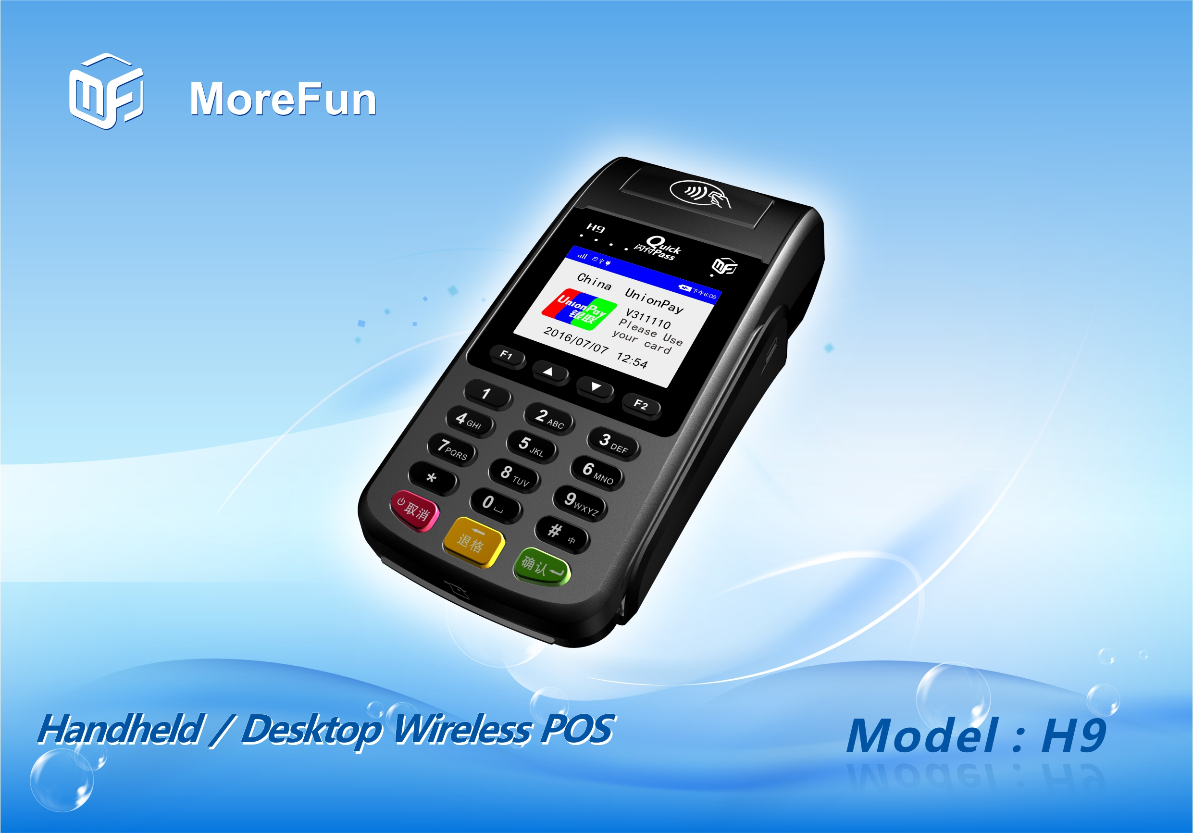

Product introduction：
H9 is a new generation of desktop / handheld wireless payment terminal developed by Fujian MoreFun Electronic Technology Co., Ltd. based on the experience accumulated in the field of traditional financial equipment and users' good feedback. The product has streamlined appearance design, meet all kinds of business needs of the existing handheld mobile terminal, also with high cost-effective, to be used as a desktop terminal, with a portable appearance and superior battery life, it is the preferred equipment for financial handheld payment, mobile payment, logistics and distribution, home payment, data collection and so on.
Product features：
- 320*240 color LCD touch screen display.
- Compact and fashion appearance, superior performance, fast response at starting up and interactive operation.
- Built-in large capacity battery, work continuously for a long time, support more transactions.

Product specification：
CPU | - High performance 32-bit security processor 120MHz
Memory | - 1MB Flash ,128KB SRAM  - External 64MB large capacity memory
Display | - 320*240 color LCD with backlight  - Touch screen, support handwriting signature
Keyboard | - 0~9 number key, *, #, confirm, cancel, delete, ect, total 19 keys
Magnetic card reader | - Support 1/2/3 magnetic track bi-directional reading  - Can support high coercivity magnetic card reading  - Can support ISO 7810、ISO7811-1,2,3,4,5,6、ISO7813 standard magnetic card reading  - Can support 0.1m/s～1m/s swiping card speed
IC card reader | - One user card base  - Support 3V or 5V card  - Support ISO7816CPU card, comform to PBOC and EMV standard
Contactless card reader | - 13.56MHZ，support ISO14443 Type A/B, Mifare one card
SAM card reader | - 1 pcs, comform to ISO7816 standard
Password keyboard | - Built-in password keyboard  - Conform to ANSI X9.8/ISO9564, ANSI, X9.9/ISO8731 standard  - Support DES, 3DES, RSA, SHA-256 and other algorithms  - Support MK/SK
Communication | - GPRS
Printer | - Built-in high-speed thermal printer, support graphic printing, 58mm width, sroll diameter 40mm
Physical interface | - One RS232 serial port
Power Supply | - 5VDC 1A
Battery | - Built-in rechargeable lithium battery: 7.4V，1500mAH
Size | - 176.6 × 83.5 × 54mm
Certification | - CCC, Telecom network authentication  - EMV/PBOC 3.0 Level1&Level2 cert.  - PBOC 3.0 contactless Level1&Level2 cert.  - PIN input device security certification  - UnionPay direct connect POS application test  - UnionPay network access certification

